**CHAPTER : 1**

# **INTRODUCTION AND LITERATURE REVIEW**

**1.1 Purpose of the Project**

Robots have become part of our life these days. Starting as replacement for workers in manufacturing industries to drone delivery, as waiters in hotels and restaurants. Autonomous robots play crucial role. The demand for the autonomous bots have been increasing continuously. So, here we are making a autonomous bot .which reduce the human effort and minimize the number of accidents caused on the roads with human mistakes. As when a vehicle is moving in heavy traffic all the effort that a human makes is on not to commit an accident. But to break it down in simple terms, it is a routine task – avoid obstacles and drive forward . This is the problem that our project addresses. Also the main purpose of the project is to reduce the fuel consumption there by reducing the emissions and saving the environment.

**1.2 Scope of the Project**

With increase in automation, bots play a key role in present generation. Prominent companies such as John Deere, Steelcase, and HP use autonomous indoor navigation bots to humanize remote conversations and to bridge the gap between formal and informal interaction. Recently, Raffi Krikorian, VP of Engineering at Twitter bought Double, one such bot, to act as his replacement when he can’t attend a meeting and to interact with his colleagues, while he is someplace else, by making Double move the isles of his office. The more autonomous they are, the higher the demand and value. Presently bots are used to maximum extent in manufacturing units. This localization and navigation bots are the future. They are used in delivery drones. The self driving cabs for which the world is waiting, this sort of bots are the key player.

**1.3 Literature Review**

**Survey details**

Chin-Kai Chang-He presented a vision-based navigation and localization system using two biologically-inspired scene understanding models which are studied from human visual capabilities: (1) Gist model which captures the holistic characteristics and layout of an image and (2) Saliency model which emulates the visual attention of primates to identify conspicuous regions in the image. There the localization system utilizes the gist features and salient regions to accurately localize the robot, while the navigation system uses the salient regions to perform visual feedback control to direct its heading and go to a user-provided goal location. He tested the system on their own robot, Beobot2.0, in an indoor and outdoor environment with a route length of 36.67m (10,890 video frames) and 138.27m (28,971 frames), respectively. On average, the robot is able to drive within 3.68cm and 8.78cm (respectively) of the center of the lane.

Phillip Dupree Research was the autonomization of the robot RHex, a highly mobile hexapodal robot built in the GRASP lab of the University of Pennsylvania, which was accomplished by the integration of a global positioning system (GPS) module into the robot. The GPS module gave the robot the ability to follow a “breadcrumb” path of GPS way-points. Once the GPS data was parsed, the coordinates of both the robot’s location and the path of waypoints were converted into flat-earth approximate Cartesian coordinates, and then inputted into a linear control system. Once this was accomplished, the robot had the ability to “know” its current position and navigate from it to any programmed point, providing there were no obstacles in its path.

Osama Hamzeh, and Ashraf Elnagar- Tele-robotic localization systems vary in implementation, but the cost of building such solutions is high. Therefore, utilizing such solutions in complex areas becomes a very difficult choice. They propose to use a low-cost localization and navigation solution that consists of a low cost Kinect sensor along with a normal laptop to control a small mobile robot. Our proposed solution involves remotely controlled mobile robot for navigating a pre-built MAP of an unknown environment. Experimental results confirm the success of the prototype design and implementation.

Todd Litman- This report explores the impacts that autonomous (also called self-driving, driverless or robotic) vehicles are likely to have on travel demands and transportation planning. It discusses autonomous vehicle benefits and costs, predicts their likely development and implementation based on experience with previous vehicle technologies, and explores how they will affect planning decisions such as optimal road, parking and public transit supply. The analysis indicates that some benefits, such as independent mobility for affluent non-drivers, may begin in the 2020s or 2030s, but most impacts, including reduced traffic and parking congestion (and therefore road and parking facility supply requirements), independent mobility for low-income people (and therefore reduced need to subsidize transit), increased safety, energy conservation and pollution reductions, will only be significant when autonomous vehicles become common and affordable, probably in the 2040s to 2060s, and some benefits may require prohibiting human-driven vehicles on certain roadways, which could take longer.

Liu and Tomizuka -proposed the Robustly-safe Automated Driving system (ROAD) which prevents or minimizes occurrences of collisions of the automated vehicle with other road participants while maintaining efficiency. In this paper, a set of design principles are elaborated as an extension of the previous work, including robust perception and cognition algorithms for environment monitoring and high level decision making and low level control algorithms for safe maneuvering of the automated vehicle.

**1.4 Knowledge gained from the Literature**

1. We have learned how to develop the algorithm.
2. Learned servo motor controlling of speed variation which helps to guide the steering.
3. Appropriate usage of arduino.
4. Information about drive.
5. Calibration of ultrasonic and IR sensors.

**1.5 Gaps Identified**

1. The technology which is present now cant be used or implemented in all existing electric vehicles.
2. The cost is very high included in existing process.
3. The present technology is not much user friendly.

## 1.6 Objectives of the work

## Make an autonomous vehicle which can take diversion against obstacles. The expected application lies in the mining, factories and construction industry where most of the jobs can be automated and thus reducing costs. To make the bot at the cheapest rate possible.

**CHAPTER: 2**

# **METHODOLGY AND EXPERIMENTAL WORK**

* 1. **Project Execution Stages**

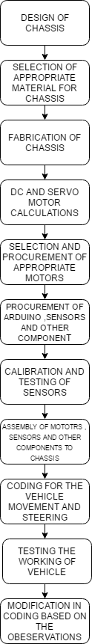

* 1. **Technical Specifications Components used:**

1. Arduino uno :

Arduino Uno is a microcontroller board based on the ATmega328P ([datasheet](http://www.atmel.com/Images/doc8161.pdf)). It has 14 digital input/output pins (of which 6 can be used as PWM outputs), 6 analog inputs, a 16 MHz quartz crystal, a USB connection, a power jack, an ICSP header and a reset button. It contains everything needed to support the microcontroller; simply connect it to a computer with a USB cable or power it with a AC-to-DC adapter or battery to get started.

The Uno differs from all preceding boards in that it does not use the FTDI USB-to-serial driver chip. Instead, it features the Atmega16U2 (Atmega8U2 up to version R2) programmed as a USB-to-serial converter. Revision 2 of the Uno board has a resistor pulling the 8U2 HWB line to ground, making it easier to put into DFU mode.

Arduino Technical specification:

|  |  |
| --- | --- |
| Microcontroller | ATmega328P |
| Operating voltage | 5v |
| Input voltage (recommended) | 7-12v |
| Input voltage (limit) | 6-20v |
| Digital I/O pins | 14(of which 6 provide PWM output) |
| PWM digital I/O pins | 6 |
| Analog input pins | 6 |
| Dc current per I/O pin | 20ma |
| Dc current for 3.3V pin | 50ma |
| Flash memory | 32kb |
| SRAM | 2kb |
| EEPROM | 1kb |
| Clock speed | 16mhz |
| Led_Builtin | 13 |
| Length | 68.6mm |
| Width | 53.4 |
| Weight | 25g |

Table: 1

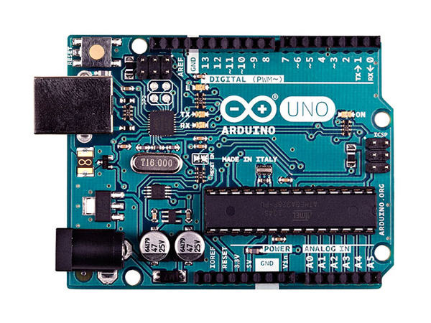

Image: 1 Arduino uno

1. IR Sensors

An [infrared sensor](https://www.elprocus.com/ir-remote-control-basics-operation-application/) is an electronic device, that emits in order to sense some aspects of the surroundings. An IR sensor can measure the heat of an object as well as detects the motion. These types of sensors measures only infrared radiation, rather than emitting it that is called as a [passive IR sensor](https://www.elprocus.com/passive-infrared-pir-sensor-with-applications/). Usually in the infrared spectrum, all the objects radiate some form of thermal radiations. These types of radiations are  invisible to our eyes, that can be detected by an infrared sensor. The emitter is simply an IR LED ([Light Emitting Diode](http://www.elprocus.com/explain-different-types-leds-working-applications-engineering-students/)) and the detector is simply an IR photodiode which is sensitive to IR light of the same wavelength as that emitted by the IR LED. When IR light falls on the photodiode, The resistances and these output voltages, change in proportion to the magnitude of the IR light received.

Infrared technology addresses a wide variety of wireless applications. The main areas are sensing and remote controls. In the electromagnetic spectrum, the infrared portion is divided into three regions: near infrared region, mid infrared region and far infrared region.

The wavelengths of these regions and their applications are shown below.

* Near infrared region — 700 nm to 1400 nm — IR sensors, fiber optic
* Mid infrared region — 1400 nm to 3000 nm — Heat sensing
* Far infrared region — 3000 nm to 1 mm — Thermal imaging

The frequency range of infrared is higher than microwave and lesser than visible light.

IR technical specification:

|  |  |
| --- | --- |
| Sensitive area | 2 elements |
| Spectral response | 5-14 µm |
| Supply voltage | 3-15v |
| Output voltage | 20mv peak-peak |
| Operating temperature | 30-70c |
| Viewing angle | 95 |
| Detection range | Up to 30 feets |
| Noise | 20µv peak-peak |

Table: 2

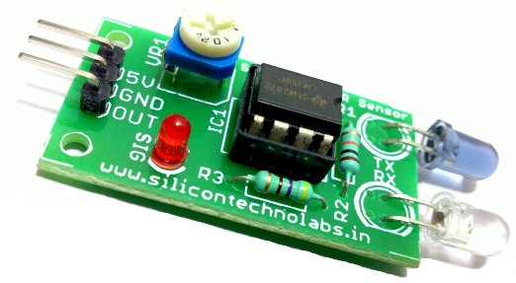

Fig: 2 IR sensor

1. L293D motor driver

L293D is a typical Motor driver or Motor Driver IC which allows DC motor to drive on either direction. L293D is a 16-pin IC which can control a set of two DC motors simultaneously in any direction. It means that you can control two [DC motor](http://www.rakeshmondal.info/High-Torque-Motor-Low-RPM-Motor) with a single L293D The l293d can drive small and quiet big motors as well.

It works on the concept of H-bridge. H-bridge is a circuit which allows the voltage to be flown in either direction. As you know voltage need to change its direction for being able to rotate the motor in clockwise or anticlockwise direction, Hence H-bridge IC are ideal for driving a DC motor.

In a single L293D chip there are two h-Bridge circuit inside the IC which can rotate two dc motor independently. Due its size it is very much used in robotic application for controlling DC motors. Given below is the pin diagram of a L293D motor controller.

There are two Enable pins on l293d. Pin 1 and pin 9, for being able to drive the motor, the pin 1 and 9 need to be high. For driving the motor with left H-bridge you need to enable pin 1 to high. And for right H-Bridge you need to make the pin 9 to high. If anyone of the either pin1 or pin9 goes low then the motor in the corresponding section will suspend working. It’s like a switch.

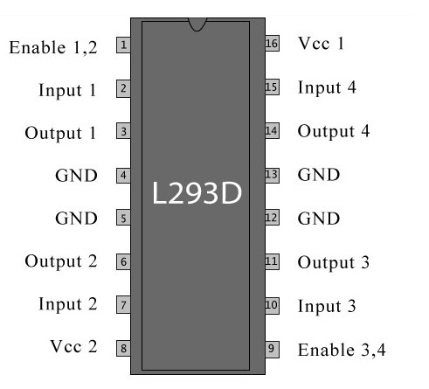

Fig: 3 L293D Pin diagram

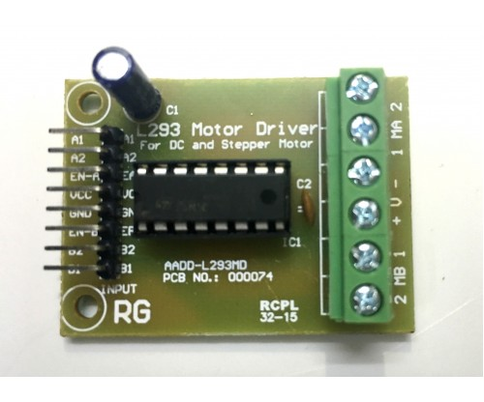

Fig: 4 L293D motor driver

1. HC SR-04 Ultrasonic sensor

This is the HC-SR04 ultrasonic ranging sensor. This economical sensor provides 2cm to 400cm of non-contact measurement functionality with a ranging accuracy that can reach up to 3mm. Each HC-SR04 module includes an ultrasonic transmitter, a receiver and a control circuit.

The Ultrasonic Sensor sends out a high-frequency sound pulse and then times how long it takes for the echo of the sound to reflect back. The sensor has 2 openings on its front. One opening transmits ultrasonic waves, (like a tiny speaker), the other receives them, (like a tiny microphone).

The speed of sound is approximately 341 meters (1100 feet) per second in air. The ultrasonic sensor uses this information along with the time difference between sending and receiving the sound pulse to determine the distance to an object. It uses the following mathematical equation:

Distance = Time x Speed of Sound divided by 2

Time = the time between when an ultrasonic wave is transmitted and when it is received

You divide this number by 2 because the sound wave has to travel to the object and back.

HC SR-04 Ultrasonic sensor technical specification:

|  |  |
| --- | --- |
| Supply voltage | 5v |
| Global current consumption | 15ma |
| Ultrasonic frequency | 40k hz |
| Maximal range | 400cm |
| Minimal range | 3cm |
| Resolution | 1cm |
| Trigger pulse width | 10µs |
| Outline dimension | 43*20*15mm |

Table: 3

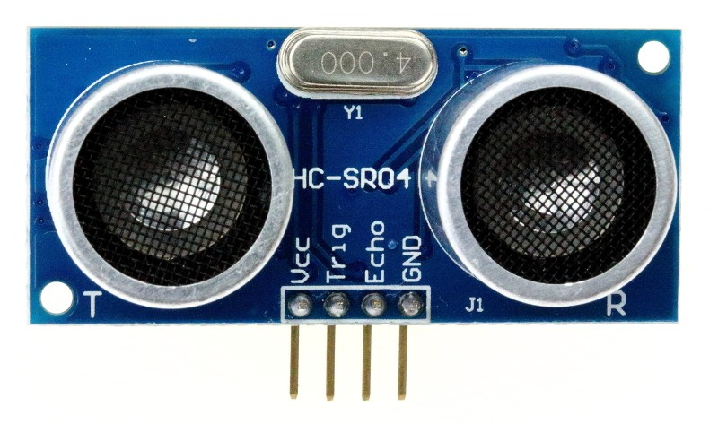

Fig: 5HC SR-04 Ultrasonic sensor

1. DC Geared Motors

A DC motor in simple words is a device that converts electrical energy (direct current system) into mechanical energy. The principle of working of a DC motor is that "whenever a current carrying conductor is placed in a magnetic field, it experiences a mechanical force". The direction of this force is given by Fleming's left hand rule. A geared DC Motor has a gear assembly attached to the motor. The speed of motor is counted in terms of rotations of the shaft per minute and is termed as RPM .The gear assembly helps in increasing the torque and reducing the speed. Using the correct combination of gears in a gear motor, its speed can be reduced to any desirable figure. This concept where gears reduce the speed of the vehicle but increase its torque is known as gear reduction. This Insight will explore all the minor and major details that make the gear head and hence the working of geared DC motor.

DC motors were the first type widely used, since they could be powered from existing direct-current lighting power distribution systems. A DC motor's speed can be controlled over a wide range, using either a variable supply voltage or by changing the strength of current in its field windings. Small DC motors are used in tools, toys, and appliances.

DC motor technical specification:

|  |  |
| --- | --- |
| Voltage | 12v |
| Rpm | 100 |
| Base motor rpm | 3000 |
| Shaft diameter | 6mm |
| Weight | 125gm |
| Torque | 5kgcm |
| No-load current (max) | 60ma |
| Load current (max) | 300ma |

Table: 4

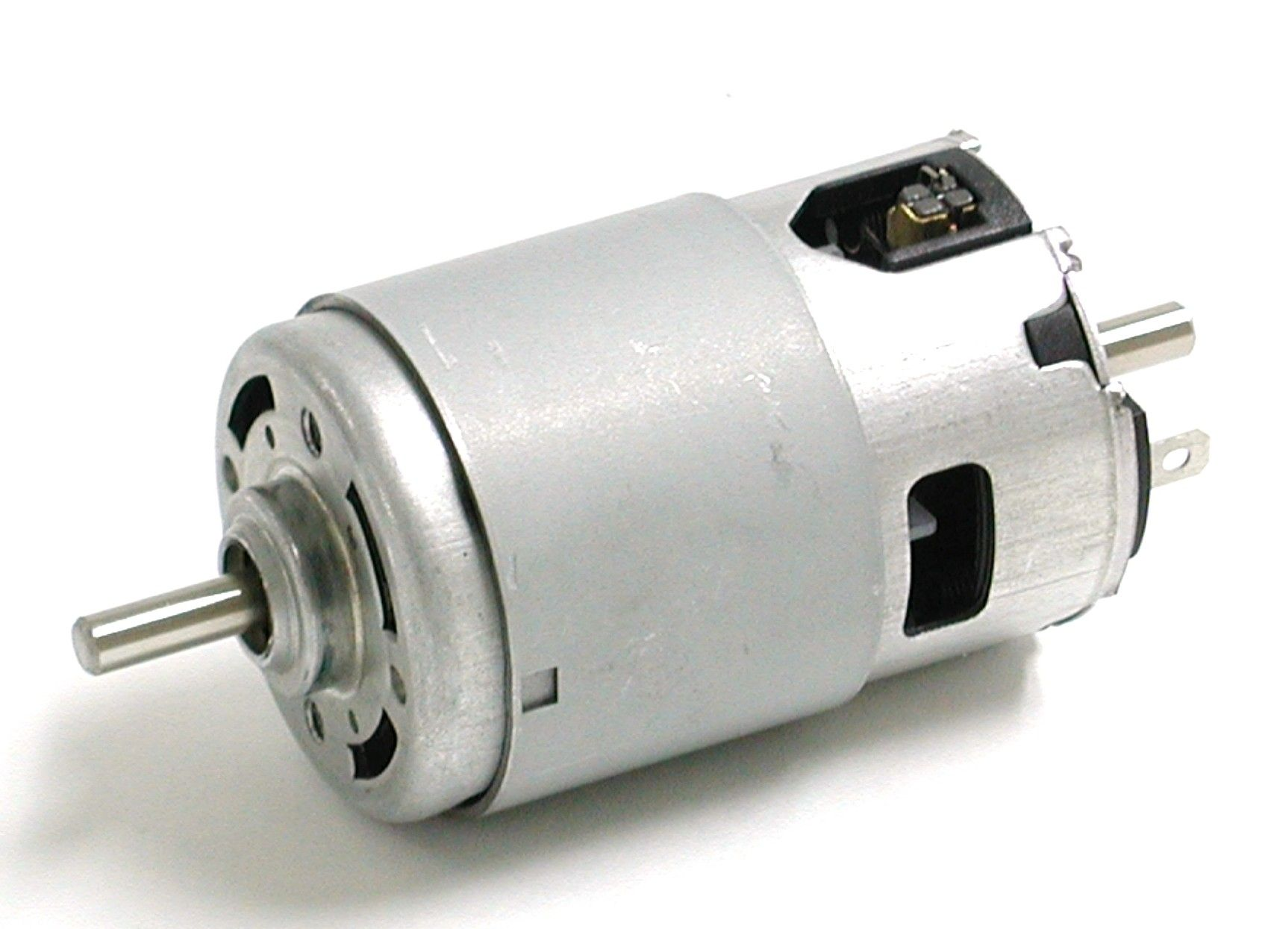

Fig: 6 DC motor

1. SG3003 servo motor

A servomotor is a [rotary actuator](https://en.wikipedia.org/wiki/Rotary_actuator) or [linear actuator](https://en.wikipedia.org/wiki/Linear_actuator) that allows for precise control of angular or linear position, velocity and acceleration.It consists of a suitable motor coupled to a sensor for position feedback. It also requires a relatively sophisticated controller, often a dedicated module designed specifically for use with servomotors.

Servomotors are not a specific class of motor although the term servomotor is often used to refer to a motor suitable for use in a [closed-loop control](https://en.wikipedia.org/wiki/Closed-loop_control) system. Servomotors are used in applications such as [robotics](https://en.wikipedia.org/wiki/Robotics), [CNC machinery](https://en.wikipedia.org/wiki/CNC_machine) or [automated manufacturing](https://en.wikipedia.org/w/index.php?title=Automated_manufacturing&action=edit&redlink=1).

A servomotor is a [closed-loop](https://en.wikipedia.org/wiki/Closed-loop_controller) [servomechanism](https://en.wikipedia.org/wiki/Servomechanism) that uses position feedback to control its motion and final position. The input to its control is a signal (either analogue or digital) representing the position commanded for the output shaft.

The motor is paired with some type of [encoder](https://en.wikipedia.org/wiki/Encoder) to provide position and speed feedback. In the simplest case, only the position is measured. The measured position of the output is compared to the command position, the external input to the controller. If the output position differs from that required, an [error signal](https://en.wikipedia.org/wiki/Error_signal) is generated which then causes the motor to rotate in either direction, as needed to bring the output shaft to the appropriate position. As the positions approach, the error signal reduces to zero and the motor stops.

SG3003 servo motor technical specification:

|  |  |
| --- | --- |
| Dimensions | 41*20*36mm |
| Weight | 37.2g |
| Output shaft style | 25 tooth spline |
| Voltage range | 4.8v-6.0v |
| No-load speed (4.8v) | 0.23sec/60deg |
| No-load speed (6.0v) | 0.19sec/60deg |
| Stall torque (4.8v) | 3.2 kg.cm |
| Stall torque (6.0v) | 4.1 kg.cm |
| Pulse amplitude | 3-5v |
| Operating temperature | -20 to +60 deg |
| Continuous rotation modifiable | Yes |
| Direction w/ increasing PWM signal | Counter clockwise |
| Motor type | 3 pole ferrite |
| Potentiometer drive | Indirect drive |
| Output shaft support | Plastic bearing |
| Gear type | Straight cut spear |
| Gear material | Nylon |
| Wire length | 12̎̎ |

Table: 5

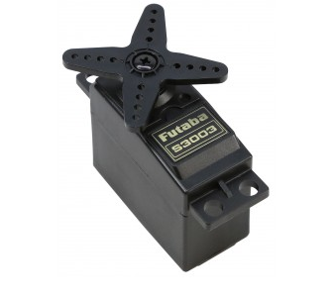

Fig: 7 servo motor

1. Acrylic board

Poly(methyl methacrylate) (PMMA), also known as acrylic or acrylic glass as well as by the trade names Plexiglas, Acrylite, Lucite, and Perspex among several others (see below), is a [transparent](https://en.wikipedia.org/wiki/Transparency_(optics)) [thermoplastic](https://en.wikipedia.org/wiki/Thermoplastic) often used in sheet form as a lightweight or shatter-resistant alternative to [glass](https://en.wikipedia.org/wiki/Soda-lime_glass). The same material can be utilised as a casting resin, in inks and coatings, and has many other uses.

Although not a type of familiar [silica](https://en.wikipedia.org/wiki/Silica)-based glass, the substance, like many thermoplastics, is often technically classified as a type of [glass](https://en.wikipedia.org/wiki/Glass) (in that it is a non-crystalline vitreous substance) hence its occasional historic designation as acrylic glass. Chemically, it is the [synthetic polymer](https://en.wikipedia.org/wiki/List_of_synthetic_polymers) of [methyl methacrylate](https://en.wikipedia.org/wiki/Methyl_methacrylate). The material was developed in 1928 in several different laboratories by many chemists, such as William Chalmers, [Otto Rohm](https://en.wikipedia.org/wiki/Otto_R%C3%B6hm) and Walter Bauer, and was first brought to market in 1933 by the [Rohm and Haas Company](https://en.wikipedia.org/wiki/Rohm_and_Haas) under the [trademark](https://en.wikipedia.org/wiki/Trademark) Plexiglas.

PMMA is an economical alternative to [polycarbonate](https://en.wikipedia.org/wiki/Polycarbonate) (PC) when extreme strength is not necessary. Additionally, PMMA does not contain the potentially harmful [bisphenol-A](https://en.wikipedia.org/wiki/Bisphenol-A" \o "Bisphenol-A) subunits found in polycarbonate. It is often preferred because of its moderate properties, easy handling and processing, and low cost. Non-modified PMMA behaves in a brittle manner when under load, especially under an [impact force](https://en.wikipedia.org/wiki/Impact_(mechanics)), and is more prone to scratching than conventional inorganic glass, but modified PMMA is sometimes able to achieve high scratch and impact resistance.

Acrylic board properties:

|  |  |
| --- | --- |
| Chemical formulae | (C5O2H8)n |
| Molar mass | Varies |
| Density | 1.18g/cm3 |
| Melting point | 1600c |
| Magnetic susceptibility | -9.06*10-6 |
| Refractive index | 1.4905 at 589.3nm |

Table: 6

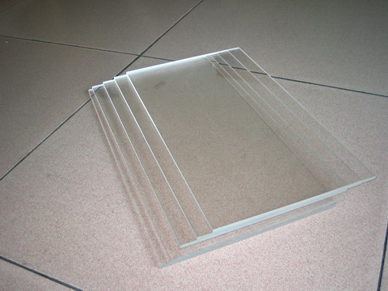

Fig: 8 acrylic board

1. Battery

The AA battery—also called a *double A* or Mignon (French for "dainty") battery—is a standard size single cell cylindrical [dry battery](https://en.wikipedia.org/wiki/Dry_battery). The [IEC 60086](https://en.wikipedia.org/wiki/IEC_60086) system calls it size R6, and [ANSI](https://en.wikipedia.org/wiki/ANSI)C18 calls it size 15.Historically, it is known as HP7 in official documentation the United Kingdom, though it is colloquially known as a "double a battery".

AA batteries are common in portable [electronic devices](https://en.wikipedia.org/wiki/Electronics). An AA battery is composed of a single [electrochemical cell](https://en.wikipedia.org/wiki/Electrochemical_cell) that may be either a primary battery (disposable) or a rechargeable battery. The exact terminal [voltage](https://en.wikipedia.org/wiki/Voltage) and capacity of an AA size battery depends on cell chemistry, however, devices designed for AA will usually only take 1.5 V unless specified by the manufacturer.

Introduced in 1907. The AA battery size was standardized by the [American National Standards Institute](https://en.wikipedia.org/wiki/American_National_Standards_Institute) (ANSI) in 1947, but it had been used in flashlights and electrical novelties for some time before formal standardization. ANSI and IEC [Battery nomenclature](https://en.wikipedia.org/wiki/Battery_nomenclature) gives several designations for cells in this size, depending on cell features and chemistry.

Battery specifications

|  |  |
| --- | --- |
| Classification | Alkaline |
| Chemical system | Zn/MnO2 |
| Designation | ANSI-15A,IEC-LR6 |
| Nominal voltage | 1.5v |
| Operating temperature | -180c-550c |
| Weight | 23gms |
| Volume | 8.1 cubic centimetres |
| Jacket | Plastic label |
| Shelf life | 10years at 210c |
| Terminal | Flat contact |

Table: 7

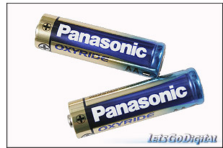

Fig:9 Battery

**2.3 Methodology**

A perfect material which can bear the load of the motor(s) and the battery which can also host the steering system so that the direction of the vehicle can be changed is selected. After the material is selected, linkages required for the steering system are fabricated so that it can be controlled using a servo motor.

Wheels are selected with an estimate of the final load. Both the rear wheels move in sync, so the rear wheels are connected to dc motor individually.

A servo motor is selected based on the steering system which has already been fabricated. Now with whole load on board, a DC motor will be selected. So the vehicle will be rear wheel drive without a gear.

After the construction of the mechanical components, Arduino, is tested with each and every sensor. Input from each of the sensors is tested and the type of input is understood for each and every sensor. To make the final product all the sensors should work in tandem and thus the algorithm is designed such that the arduino handles all the inputs and makes the decisions.

The algorithm is designed based on the end-product requirement. The end-product should have the following features.

* If any obstacle is found, based on the speed the vehicle should steer itself or should come to a halt.
* If any moving vehicle is found, based on the behaviour of the vehicle, the ADV should apply brakes or should steer itself.
* Based on the behaviour of the side vehicles and the rear vehicles, the data from the sensors should be taken with which the speed, steering angle and few others should be controlled.
* When a speed braker or a pot hole is found, ADV should make the correct decision to slow down the vehicle, so that the passengers will feel comfortable.
* ADV should work even in very low light conditions without fail.
* ADV should sense some routine sounds like horns and should make way for the vehicles incoming or outgoing.
* Based on the temperature and humidity of the environment the Air conditioning should be switched on with the input from the user.
* For a given interval of time the arduino should connect to the internet and dump the data. If required the user should be able to control the vehicle using internet.

(Optional) Based on the data collected and stored with each and every ride, the vehicle should use machine learning and take its own decisions.

**2.4 Implementation**

Power Calculations:

**Dc Motor:**

**Data:**

Vehicle weight: 1.2 kg

Vehicle speed: 5km/h

Coefficient of rolling resistance Cr :0.3

Drag coefficient Cd: 1.5

Representative frontal width: 0.25m

Representative frontal height: 0.0375m

Air density: 1.2 kg/m^3

Estimated efficiency: 80%

Power =Force *velocity

Force: force required to over come the rolling friction force and air drag force.

Rolling frictional force = Cr*mg

Air drag force= Cd* density*A*v^2

**Assumption:**

Velocity v=5km/h

Calculation:

Rolling frictional force =0.3*1.2*9.81= 3.5316

Air drag force =1.5*1.2*0.25*0.0375*1.38*1.38= 0.0322

Force = 3.5316+0.0322 = 3.5638

Power = 3.5638*1.38= 4.918W

Efficiency (80%) = 4.918*100/80 = 6.1475W

Final power required: 6.1475W

**Servo motor:**

**Data:**

Mass acting on each tyre:1.2/4= 0.3kg

Radius of each tyre: 3.75

Thickness of tyre:2cm

**Calculation:**

Moment of inertia (I)=(1/4) mr^2+(1/12)ml^2

=0.25*0.3*3.75*3.75+0.0833*0.3*2*2

= 1.055+0.09996

=1.155 kgcm^2

=1.155*10^-4 Kg/m^2

**Assumption:**

N=60rpm

Ω=6.2832rad/sec

α=6.2832rad/sec^2

Taking t=1sec

Torque required to steer a wheel=T1

Torque T1=i*α

=1.155*6.2832

=7.257Nm

Now, force required at the end of the link to provide the above torque,

F1*L2=T1

F1=7.257/0.0125

=580.56768N

Servo motor Torque (which can provide this amount of force at end of the link)

=580.56798*0.25

=145.142N/m

=145.142/0.098kgfcm

= 1481.04kgfcm

Servo motor torque for both wheels=0.148*2

=0.3 kgfcm.

**2.5 Arduino code**

#include <Servo.h>

#define echopin_C 9 // echo pin

#define trigpin_C 8 // Trigger pin

int maximumRange = 30;

int IR_Left = 2;

int IR_Right = 3;

int L, R;

long duration_C,distance_C;

Servo myservo;

void setup() {

myservo.attach(10);

myservo.write(33);//Initialization

delay(100);

// Serial.begin (9600);

pinMode (trigpin_C, OUTPUT);

pinMode (echopin_C, INPUT );

pinMode (IR_Left, INPUT );

pinMode (IR_Right, INPUT );

pinMode (4, OUTPUT);

pinMode (5, OUTPUT);

pinMode (6, OUTPUT);

pinMode (7, OUTPUT);

}

void loop ()

{

L=digitalRead(IR_Left);

R=digitalRead(IR_Right);

{

digitalWrite(trigpin_C,LOW);

delayMicroseconds(2);

digitalWrite(trigpin_C,HIGH);

delayMicroseconds(10);

duration_C=pulseIn (echopin_C,HIGH);

distance_C= duration_C/58.2;

// delay (50);

//Serial.println(distance_C);

}

if ( distance_C > 30)

{

myservo.write(33);

delay(100);

digitalWrite(4,HIGH);

digitalWrite(5,LOW);

digitalWrite(6,HIGH);

digitalWrite(7,LOW);

}

if ( R== HIGH)

{

myservo.write(3);

digitalWrite(4,HIGH);

digitalWrite(5,LOW);

digitalWrite(6,HIGH);

digitalWrite(7,LOW);

delay(1000);

}

if ( L== HIGH)

{

myservo.write(63);

digitalWrite(4,HIGH);

digitalWrite(5,LOW);

digitalWrite(6,HIGH);

digitalWrite(7,LOW);

delay(1000);

}

else if (distance_C > 20 && distance_C <= 30 )

{

myservo.write(63);

delay(100);

digitalWrite(4,HIGH);

digitalWrite(5,LOW);

digitalWrite(6,HIGH);

digitalWrite(7,LOW);

delay(1500);

}

else if ( distance_C > 10 && distance_C < 20 )

{

myservo.write(3);

delay(100);

digitalWrite(4,LOW);

digitalWrite(5,HIGH);

digitalWrite(6,LOW);

digitalWrite(7,HIGH);

delay(2000);

}

else if (distance_C < 10)

{ digitalWrite(4,HIGH);

digitalWrite(5,HIGH);

digitalWrite(6,HIGH);

digitalWrite(7,HIGH);

delay(500);

}

}

**2.6 Realistic and Design Constraints addressed**

## Design Elements included (Atleast one apart from the marked ones)

*(List the approved evaluation questions the evaluation should answer to aid decision-making.)*

Engineering Standards* Prototype and Fabrication

Design Analysis* Experimentation

Modelling and Simulation Software Development

## 

## Realistic Constraints to be addressed (Atleast two to be selected)

Economic Ethical

Environmental Health and Safety

Social Manufacturability

Political Sustainability

**References**

# Vassilis Varveropoulos. Robot Localization and Map Construction Using Sonar Data.

# Osama Hamzeh, and Ashraf Elnagar. Localization and Navigation of Autonomous Indoor Mobile Robots

1. Erickson H.; LaValle M., Navigation among visually connected sets of partially distinguishable landmarks, Submitted in partial fulfillment of the requirements for the degree of Master of Science in Computer Science in the Graduate College of the University of Illinois at UrbanaChampaign, 2012 [Tathe, A., Ghodke, M. and Nikalje, A.P., 2010. A brief review: biomaterials and their application. *International Journal of Pharmacy and Pharmaceutical Sciences*, *2*(4), pp.19-23.
2. Chin-Kai Chang* Christian Siagian* Laurent Itti. Mobile Robot Vision Navigation & Localization Using Gist and Saliency
3. G. Schindler, M. Brown, and R. Szeliski, “City-scale location recognition,” in Computer Vision and Pattern Recognition, IEEE Computer Society Conference on, vol. 0. Los Alamitos, CA, USA: IEEE Computer Society, 2007, pp. 1–7.
4. Phillip Dupree (Mechanical Engineering) - Columbia University. Autonomizatio of a mobile hexapedal robot using a GPS.
5. <https://en.wikipedia.org/wiki/Autonomous_car>
6. https://www.wired.com/tag/autonomous-vehicles/